CLIFTONETTES NETBALL CLUB PONTINS TOURNAMENT 2008 U15 REPORT Chloe Gibson Team Manager

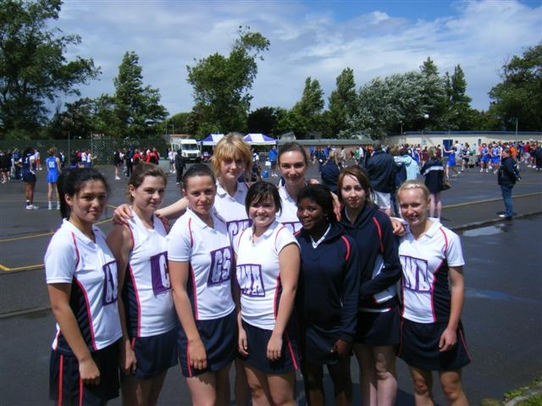
SQUAD: E. Alvey M. Anthony C. Duckworth A. Ford A. Hawkins C. Macgillivray H. Orsborn S. Reed R. Walker

SCORES: v. Devon WON 3- 1 v. Rushmore WON 13- 2 v. Eagles LOST 4- 7 v. Turnford WON 8- 3 v. Olney WON
9- 0 v. Swan WON 9- 4 v. Lincoln WON 5- 2

Qualified for the CUP: v Hertford Hornets DREW 6- 6 v. Cliff Park Hawks WON 5- 2 v Oldham WON 6- 5

Quarter Finals: v Tameside LOST 5- 6

What a weekend. The weather was awful BUT the netball was brilliant. Cliftonettes won all their matches in their section fairly easily then came up against a physical & talented team- Eagles. Cliftonettes lost this match but managed to gain a point by gaining half the opposition’s score.
On the Sunday the weather was worse, play was delayed for an hour so the courts could be cleared of water.
First match versus Hertford Hornets, Cliftonettes real bogey team. At half time Cliftonettes were 1- 3 down but the team showed great determination & pulled the score back to 6- 6. If there had been a couple more seconds left we would have WON because as the whistle blew for full time Chavonne was preparing to take her shot, she took it & it went in!!!

Next match versus Cliff Park Hawks. The team went in wanting to win & knew that they needed a good goal difference, having drawn the first match, if they wanted to progress further. They won 5- 3.

The last match in the Cup section was against Oldham. This was going to be a tough game. Hertford had lost to them & not gained half score so we knew what had to be done. The game started well with Cliftonettes gaining a lead 2- 0, but Oldham would keep fighting & at half time it was 2- 2.
In the second half it was goal for goal neither team could get a good lead. Oldham took the ball into their circle & had a shot which was blocked by Rose. We took the ball down the court, into our circle & scored levelling the score to 5- 5. It was Cliftonettes centre pass all we had to do was keep it, however it wasn’t that simple. The centre pass was turned over by the opposition, we then got an interception (sorry cannot remember who got it as I was so excited), took the ball into the circle & scored. We were ahead & then the whistle blew for full time, we had won. The girls’ faces were a picture it was as if they had won the whole tournament.

We progressed to the Quarter Finals to play Tameside from the North West. Another interesting game. Cliftonettes went down 1- 5 in the first half due to our stray passes & their accurate feeding & shooting. In the second half a more determined & focused Cliftonettes team took the court winning that half 3- 0 but it was not enough & we were defeated by 1 goal.

Congratulations to the whole squad who attended Pontins. You played some fantastic netball & should be really pleased with your achievement. You were a credit to yourselves & the club. Well Done.

